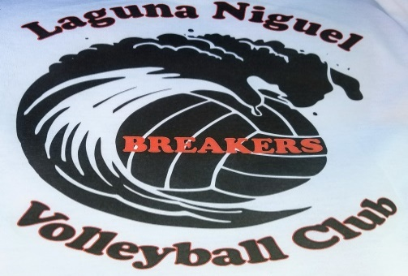

U13 2022- Summer Session
June 30th – September 1st

Practices held @ McDowell School

Thursdays – 5:30pm – 7:30pm
Saturdays - 9am - 11am

OCVH Tournaments:
To be Announced….

********************** Registration Form ************************
My child ______________________________ has permission
to participate in the Laguna Niguel Breakers Volleyball Club.
Parent Name ____________________________ Phone _____________
Parent Signature _____________________________ Date __________
Cost: $250 - Please make checks payable to:
Scott Myers or Venmo (ScottMyers@Scott-Myers-55)

